JavaScript Task (29 aug 2025)
Name: Manas Pinjarkar
Prn: 23070521089
Sem/Sec: 5th (B)
Task1:
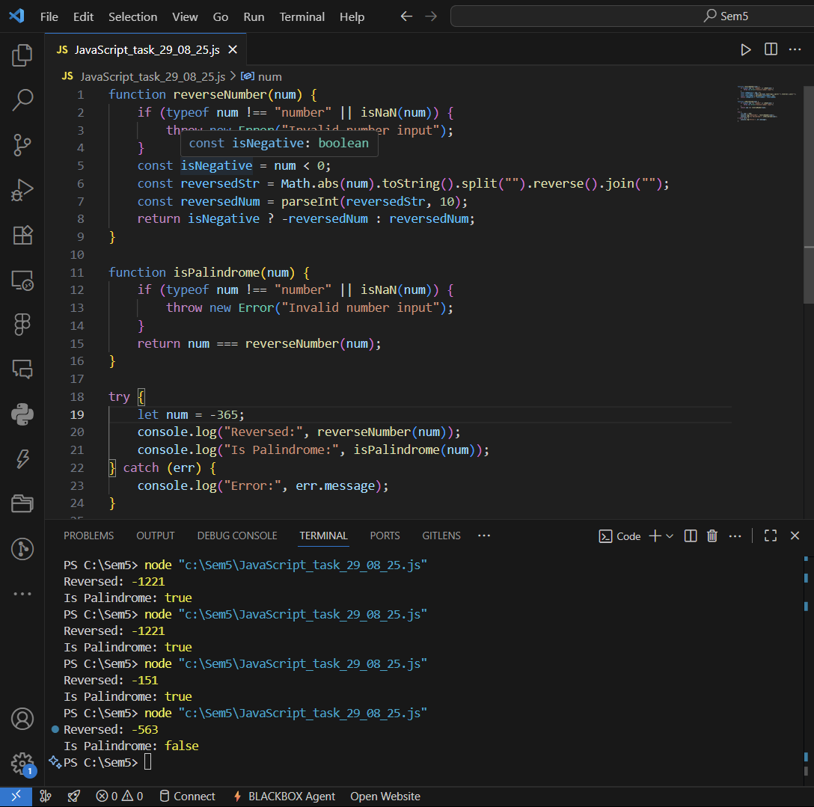

Task3:
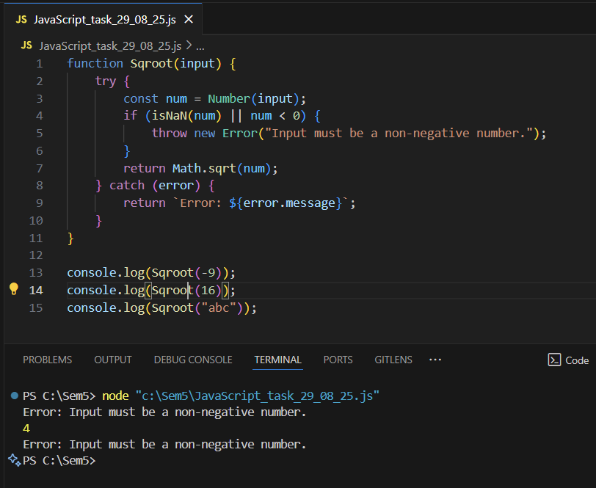
Task4:
